Project proposal

On

**Hostel Management System**

Sudip Lamichhane

Computing Project

Level 5 Diploma in Computing

Softwarica College of IT and E-Commerce

Kathmandu , Nepal

3 Jan 2019

Submitted to : Kiran Rana

Table of Contents

1 Introduction 4

1.1 Project Introduction 4

1.2 Justification for project 4

1.2.1 Background of the project 4

1.2.2 Problem Statement 4

1.3 Description of the project 5

1.3.1 Features 5

2 Project scope 5

2.1 Scope and limitation of project 5

2.2 Aims and Objectives 5

3. Development methodology 6

3.1 Methodology Used 6

3.2 Design pattern 7

3.3 System Architecture 8

4. Work Breakdown Structure (WBS) / Scheduling 9

4.1 work breakdown structure 9

4.2 Milestones 10

4.3 scheduling/ Gantt chart 11

5. Risk management 13

6. Configuration Management 15

7. Conclusion of the project 16

8. References 17

Figure 1 Waterfall Model 6

Figure 2 MVC pattern 7

Figure 3 3tier Architecture 8

Figure 4 Work breakdown structure 9

Figure 5 Gantt chart 12

Figure 6 Gantt chart in diagram 13

# Introduction

## 1.1 Project Introduction

Hostel Management is Customize and user friendly software for hostel which provides hostel information, hostel room information and hostel account information. This software helps to manage the record of students, staff and generating the report of staffs and students by the admin section. This is a web based application so students or any normal people can book from the online. Hostel management system allocates lots of features which help to solve the problem of hostel in near future.

## Justification for project

### Background of the project

### 1.2.2 Problem Statement

For the past few years the numbers of increasing hostel institutions are increasing rapidly. And hence there is a lot of strain on the person who are running the hostel and software’s are not usually used in this context. This particular project deals with the problem on managing a hostel and avoids the problem which occurs when carried manually. It is difficult to find the records manually so that’s why this software helps to find easily and quickly. This system automatically calculates all the bills and generating the reports of students and staff.

## Description of the project

### Features

The features of the project are as listed below:

* Long term storage of system
* Generating students and staff bills and report
* Utilization of time and workforce
* Booking facility

# Project scope

## Scope and limitation of project

Hostel management system software that will be used for maintaining the records in an organized manner and to replace old paper work system. This project aims at automating the hostel management for smooth working of the hostel by automating all the activities. Generating the student and staff bill will be automated.

There is also a limitation of this application. Online payment is not available in this application. There is not available of fingerprint attendance system for students and staff in this application.

## Aims and Objectives

The mains mottos of these projects are as follows:

* Lots of students have problems of searching hostel and their free structure which they affordable or not that is why it is essential.
* It is difficult to manage the all the records in paper based.
* To know the students record for long term period.

The objectives of this project are as follows:

* To replace the old system which is much more time consuming.
* To generate the report and bill
* To provide the quick response with very accurate response as when required
* Check in and check out of students

# 3. Development methodology

## 3.1 Methodology Used

I am using waterfall model in my project because there are many advantages of using this in my project. In waterfall model there are six different phases i.e. Requirement analysis, system design, implementation, testing, deployment and maintenance. In this model, phases do not overlap. There are some advantages of this model they are:

* All the requirements are very well document, clear and fixed.
* Product definition is stable.
* Time period is fixed in this model.

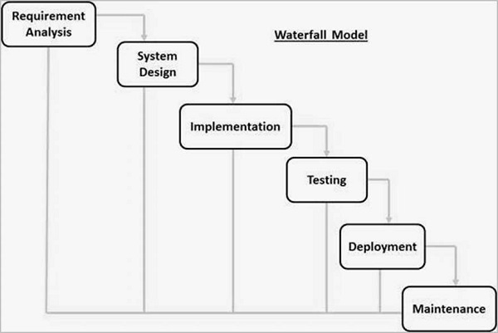

Figure Waterfall Model

## 3.2 Design pattern

I am using MVC design pattern in my project. It stands for model-view-controller. The pattern specifies where each kind of logic should be located in the application. The UI logic belongs in the view. Input logic belongs in the controller. Business logic belongs in the model. This separation helps you manage complexity when you build an application, because it enables you to focus on one aspect of the implementation at a time. For example, you can focus on the view without depending on the business logic.

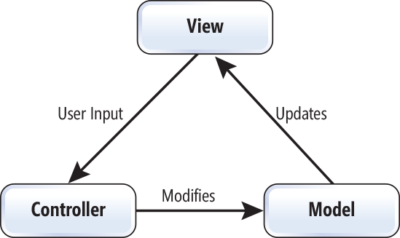

Figure MVC pattern

## 3.3 System Architecture

I am going to use 3-tier architecture. It is a software architecture which is composed of 3 layers of logical computing. This architecture often used in specific client server system. It provides many benefits by modularizing the user interface, business logic and data storage layer. For example, the user interface of a web application could be redeveloped or modernized without affecting the underlying functional business and data access logic underneath. The main benefits of using this architecture are as follows:

* Speed of development
* Scalability
* Performance
* Availability

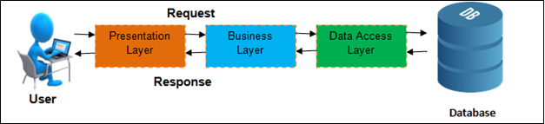

Figure 3tier Architecture

# 4. Work Breakdown Structure (WBS) / Scheduling

## 4.1 work breakdown structure

Work breakdown structure (or WBS) is a hierarchical tree structure that shows your project and breaks it down into smaller portions. The aim of a WBS is to make a large project more manageable. Breaking down into smaller chunks means work can be done simultaneously by different team members, leading to better team productivity and easier project management overall.

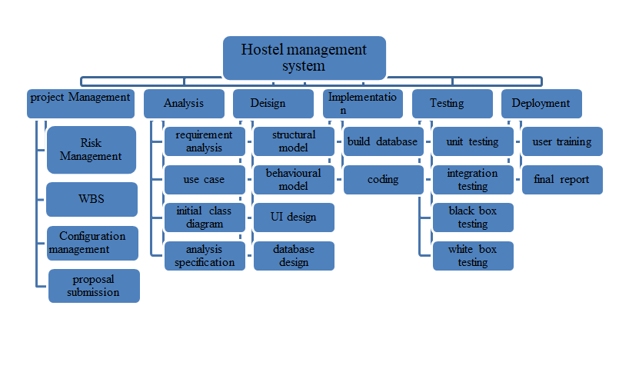

Figure Work breakdown structure

## 4.2 Milestones

|  |  |
| --- | --- |
| **Milestones** | **Date** |
| **Project Management**  Risk Management  WBS  Configuration Management  Proposal Submission | 12-21-2018 to 1-3-2019  12-21-2018 to 12-25-2018  12-26-2018 to 12-27-2018  12-28-2018 to 12-30-2018  12-31-2018 t0 1-3-2019 |
| **Analysis**  Requirement analysis  Use case  architecture  analysis specification | 1-4-2019 to 1-28-2019  1-4-2019 to 1-13-2019  1-14-2019 to 1-18-2019  1-19-2019 to 1-23-2019  1-24-2019 to 1-28-2019 |
| **Design**  Structural Diagram  Behavioral Diagram  UI Design  Database Design (ER , Data Dictionary) | 1-29-2019 to 2-27-2019  1-29-2019 to 2-7-2019  2-8-2019 to 2-12-2019  2-13-2019 to 2-22-2019  2-23-2019 to 2-27-2019 |
| **Implementation**  Building Database  Coding | 2-28-2019 to 3-31-2019  2-28-2019 to 3-11-2019  3-12-2019 to 3-31-2019 |
| **Testing**  Unit Testing  Integration Testing  Black box Testing  White box Testing | 4-1-2019 to 4-10-2019  4-1-2019 to 4-2--2019  4-3-2019 to 4-5-2019  4-6-2019 to 4-8-2019  4-9-2019 to 4-10-2019 |
| **Deployment**  User Training  Final Report | 4-11-2019 to 4-20-2019  4-11-2019 to 4-15-2019  4-16-2019 to 4-20-2019 |

**Description of Milestones:**

* **Project Management (14 days/dec21)**

For risk management I have allocate 5 days and for WBS 2 days and for configuration management 3 days and proposal for 4 days.

* **Analysis ( 25days/ jan4)**

For requirement I have allocate 10days and for use case 5 days and architecture for 5 days and analysis specification for 5 days.

* **Design( 30days/ jan29)**

For structural model I have allocate 10days and for behavioral model 5days and UI design for 10days and database design 5 days.

* **Implementation ( 32days / feb28)**

I have allocated implementation for 30 days. For database develop 12days and for coding 20days.

* **Testing (10days / apr1)**

There are four testing I have allocated 10days for all testing. For unit testing 2days and for integration testing 3 days and for black box testing 3days and white box testing 2 days

* **Deployment ( 10days / apr11)**

I have allocated 10days for deployment. For user training I have allocated 5 days and for final report 5days.

## 4.3 scheduling/ Gantt chart

The project schedule is often used in conjunction with a [Work Breakdown Structure (WBS)](https://alpha.wrke.io/project-management-guide/glossary/#wbs) as a way to evenly distribute work among team members. The project schedule should be updated on a regular basis in order to gain a better understanding of the project’s current status.

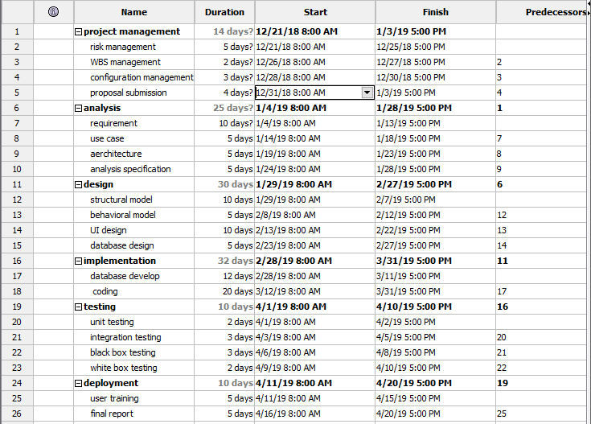

Figure Gantt chart

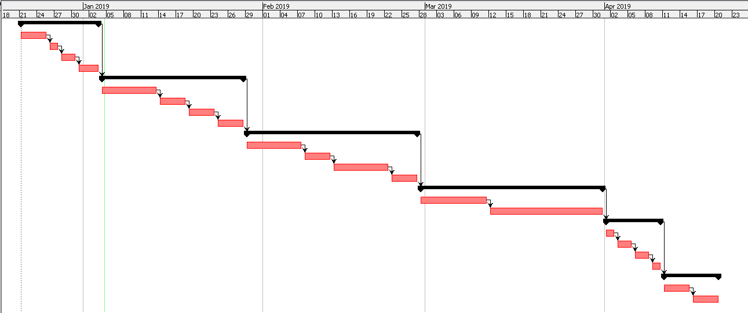

Figure Gantt chart in diagram

# 5. Risk management

Risk management is a process of identifying the risk and controlling the threats to an organization’s capital and earnings.

Risk can be controlled by identifying the risk before starting the project. Controlling risk isn't as bad as it sounds. Risks aren't necessarily eliminated or minimized. [Risk management](http://management.simplicable.com/management/new/risk-management-guide) aims to accept risks that make sense and reduce risks where possible.   
The process of controlling risk begins with identifying a list of risks and assessing the probability and impact of each risk. Controls are identified and implemented for each risk.

Risk Likelihood values are shown as follows

|  |  |
| --- | --- |
| Likelihood | Value |
| Low | 1 |
| Medium | 2 |
| High | 3 |

Risk Consequence values are shown below

|  |  |
| --- | --- |
| Consequence | Value |
| Very low | 1 |
| Low | 2 |
| Medium | 3 |
| High | 4 |
| Very High | 5 |

|  |  |  |  |  |  |
| --- | --- | --- | --- | --- | --- |
| S.N | Risk | Likelihood | Consequences | Impact | Solution |
| 1 | Hard disk failure | 1 | 5 | 5 | Back up facility should be implementing. |
| 2 | Sudden growth in requirement | 3 | 3 | 9 | Requirement should be clear and documented. |
| 3 | Employee turnover | 1 | 3 | 3 | Ensures that your employee is satisfying with his budget or not. |
| 4 | Lack of budget | 2 | 5 | 10 | Estimates the budget before start any project and offer actual budget from the customers. |
| 5 | Procedural risk | 2 | 4 | 8 | Hire the proper person who can handle his/her responsibilities and well trained. |
| 6 |  |  |  |  |  |
| 7 |  |  |  |  |  |

# 6. Configuration Management

# 7. Conclusion of the project

# 8. References

1. Documentation Hotel Management System. 2019. Documentation Hotel Management System. [ONLINE] Available at: <https://www.slideshare.net/salmanrana143/documentation-hotel-management-system>. [Accessed 05 January 2019].
2. Hostel management. 2019. Hostel management. [ONLINE] Available at: <https://www.slideshare.net/hemusajwan/hostel-management-54611747>. [Accessed 05 January 2019]
3. Hostel Management System . 2019. Hostel Management System . [ONLINE] Available at: <https://www.slideshare.net/RegmiBhanu/presentation-hostel-mgmt-by-bhanu-regmi>. [Accessed 05 January 2019]
4. Hostel Management system Report. 2019. Hostel Management system Report. [ONLINE] Available at: <https://www.slideshare.net/PrasoonRawat/hostel-management-system-report>. [Accessed 05 January 2019].
5. tutorialspoint.com. 2019. SDLC Waterfall Model. [ONLINE] Available at: <https://www.tutorialspoint.com/sdlc/sdlc_waterfall_model.htm>. [Accessed 05 January 2019].
6. Medium. 2019. Why MVC Architecture? – Socratic Solution – Medium. [ONLINE] Available at: <https://medium.com/@socraticsol/why-mvc-architecture-e833e28e0c76>. [Accessed 05 January 2019].
7. Project Management Guide. 2019. What is a Project Schedule in Project Management? - Wrike. [ONLINE] Available at: <https://www.wrike.com/project-management-guide/faq/what-is-a-project-schedule-in-project-management/>. [Accessed 05 January 2019].
8. JReport. 2019. 3-Tier Architecture: A Complete Overview - JReport. [ONLINE] Available at: <https://www.jinfonet.com/resources/bi-defined/3-tier-architecture-complete-overview/>. [Accessed 05 January 2019].
9. Project Management Guide. 2019. What is Work Breakdown Structure in Project Management? - Project Management Guide. [ONLINE] Available at: <https://www.wrike.com/project-management-guide/faq/what-is-work-breakdown-structure-in-project-management/>. [Accessed 05 January 2019].